CUMULATIVE VALUE OF GRANTS AND EQUIPMENT PURCHASED
Selected grants and purchases supported since 1993 | Latest recorded cumulative value: $2,074,136
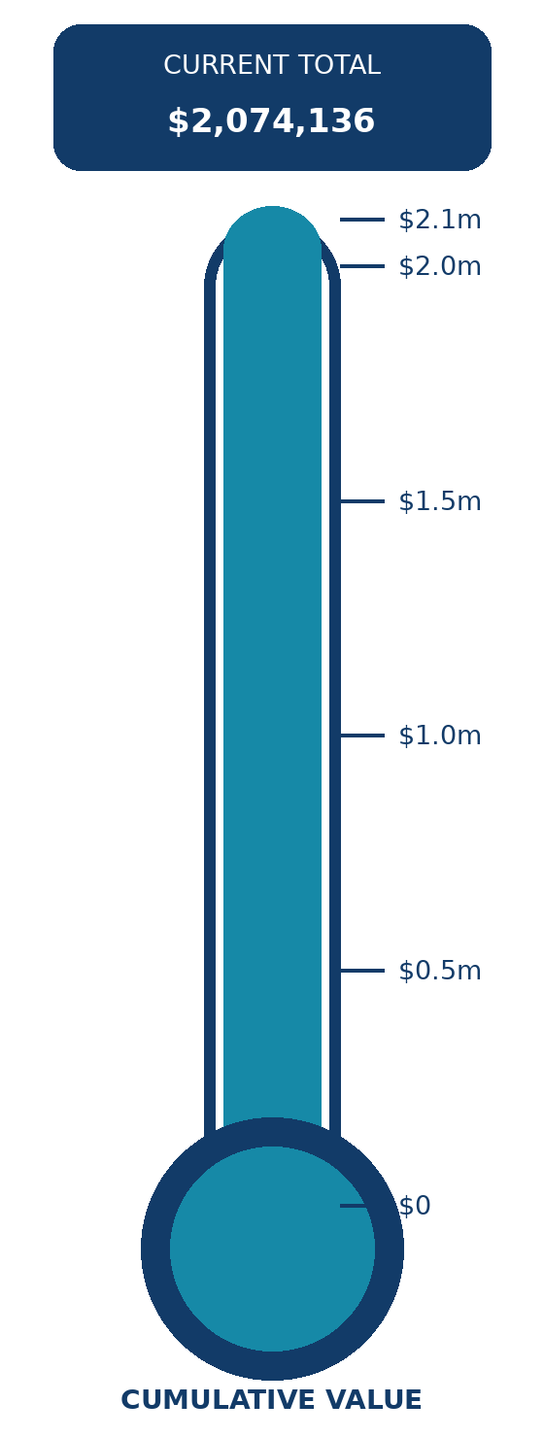
  YEAR | TOTAL | EXAMPLES OF GRANTS AND PURCHASES
  2024 | $2,074,136 | Anamata Cafe: clinic bed, two blood-pressure monitors and an otoscope  Taupo Hospital registered nurses: emergency and trauma-care training  Television wiring
  2023 | $2,066,257 | Replacement of 16 televisions in Taupo Hospital's Inpatient Unit
  2022 | $2,049,362 | Two chemotherapy infusion chairs; an AccuVein 500 with charger and hands-free stand; and artwork for the paediatric assessment and treatment rooms
  2019 | $2,023,250 | Echocardiogram for Taupo Hospital
  2018 | $1,740,141 | Taupo Bowling Club - defibrillator
  2016 | $1,739,194 | Taupo Chaplaincy - training for a multi-denominational pastor  Emergency toiletry gift bags for patients unexpectedly admitted to the inpatient ward  Anamata Cafe - youth aid equipment  Lake Taupo Hospice Trust - replacement of two worn-out syringe drivers
  2014 | $1,728,155 | Redevelopment of Taupo Hospital  Gym club - two heat pumps  Apopo Youth Development support  Parents Centre Tiny Tots demonstration gear  Anamata Cafe - immunisation fridge
  2013 | $851,528 | Care-pack materials for the Taupo Volunteer Transport Group
  2012 | $846,528 | Care toiletry packs  Taupo Volunteer Transport Group  Taupo Community Gardens  Diabetes insulin pump
  2011 | $826,519 | Three X-ray viewers for the oral dental service  CAFE for Youth Health  Diabetes insulin pump  Care toiletry packs for the Volunteer Transport Group  Radio-tracking kits for Alzheimer's  Lions Cancer Society Lodge, Hamilton  Sport Waikato - wellbeing exercise for senior citizens
  2010 | $771,253 | Taupo Volunteer Transport Group  Reclining lift chairs for the hospital
  2009 | $743,975 | Consumables for children with diabetes  Glucose-monitoring device  Rescue helicopter defibrillator
  2008 | $718,563 | Geotherm rescue bag for the rescue helicopter  Geotherm rescue blanket for St John  Lake Taupo Hospice Trust - two Archimedes bath lifters
  2007 | $705,741 | Total value of equipment and grants since 1993

